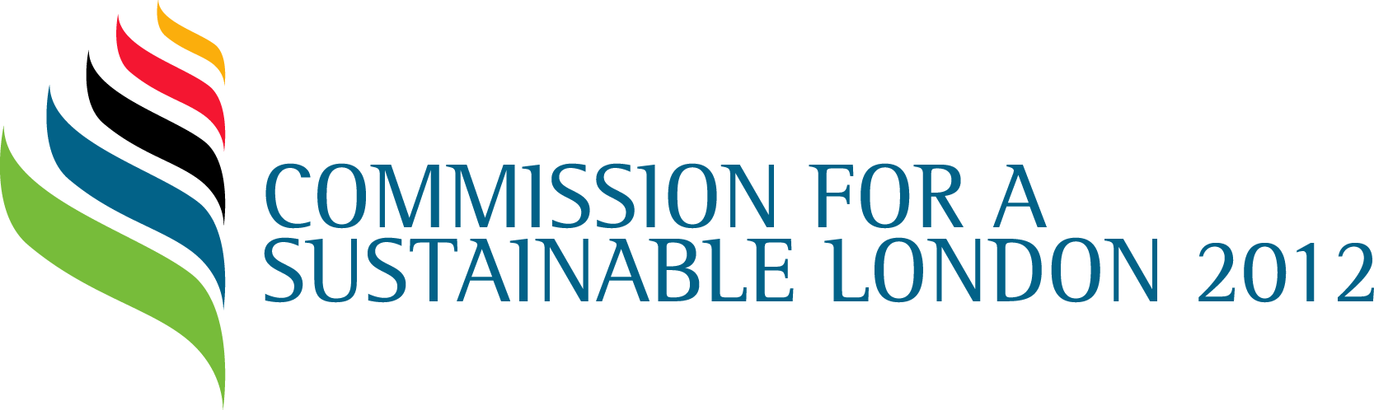

Report on London 2012 shows how ‘greenest Games’ could benefit UK

International events industry now aspires to Games-level sustainability

Embargoed until 00.01 Wednesday 20 March 2013, UK: The Commission for a Sustainable London 2012 today publishes its final post-games review, titled Making a Difference.

The London 2012 Games were widely described as ‘the greenest Games ever’, and have inspired wider sustainable practice in the events industry around the world. This positive ‘knock-on effect’ has outweighed any negative impact of London’s decision to host the Games.

The Commission’s final report looks at the Games’ sustainability achievements, and if these successes can be replicated in the UK and beyond. While there has been some excellent examples of action to embed the lessons learnt from the Games, through for example the Government’s on-going support for 2012 learning legacy web portal, there is still more to be done.

The Commission’s findings point to two main factors holding back widespread adoption of sustainable practice in the UK: firstly, slowness in government action in embedding sustainability in government procurement; and secondly, the need for more independent oversight to ensure that sustainability targets in all sectors are met. The Commission has recommended the government revisit advice to embed sustainability into the construction sector, and that major projects open themselves up to independent scrutiny of their sustainability commitments.

The Commission’s report also examined the issue of corporate sponsorship, which raised some unresolved ethical concerns during London 2012. Issues such as the use forced labour and excessive working hours in supply chains remain a problem for many industries as a whole.

To combat this problem in the Olympic and Paralympic world, the Commission’s report recommends that the IOC and other sports bodies work together to develop an ethical framework as a means of encouraging sponsors to improve human rights in the supply chain.

Shaun McCarthy, Chair of the Commission for a Sustainable London 2012, said:

“London 2012 was the first games to be monitored by an independent sustainability body. It was a ground-breaking decision seven years ago when we were first established. We’ve proved that the concept works, and now we’re seeing evidence of Commission-style assurance being used on large-scale private developments around the world.’

“However there is some way to go before the model is embedded in the UK public sector. London and the UK is looking to host a number of high profile events in the coming years and are well placed to take advantage of London 2012’s sustainability successes and lessons learnt. Internationally, Rio 2016 and the 34th America’s Cup in San Francisco have already demonstrated a commitment to cutting edge sustainability goals and we look forward to even better sustainability outcomes from the UK into the future. So much good has come from the Games, it’s up to government and the private sector to adopt Olympic best practice and ensure the legacy lives on.”

The Commission’s recommendations to overcome these problems are:

- The Department of Business, Information and Skills should facilitate more coordinated research into sustainability in construction. The Commission also notes that the government can lead by example by using a sustainable model for its own procurement, and promoting sustainability best practice within smaller construction projects.

- That future major developments and infrastructure projects subject themselves to independent strategic assurance, and follow the ODA’s example by leaving a legacy of knowledge behind. The report found that there are no current plans for a new sustainability assurance body in London or the UK. An independent evaluation has confirmed that a body similar to the Commission could add value to any large-scale event or project.

- That the London Food Board consider a long term legacy initiative built on the lessons from the Food Legacy Pledge, including waste commitments in partnership with WRAP

- That the IOC and other sport governing bodies engage constructively with independent bodies to develop an ethical framework and a process of engagement with sponsors and a shared service to consistently and continuously address human rights in the supply chain.

The Making a Difference report can be downloaded in PDF format from: http://www.cslondon.org/wp-content/uploads/downloads/2013/CSL-Making-a-Difference-2013.pdf .

~ends~
Notes for editors

- The Commission closes down on 31 March 2013, but all documents, such as reports, will remain online and publicly available.

About the Commission for a Sustainable London 2012:

The aim of the Commission is to provide independent assurance and commentary in order to enable the sustainability objectives of the London 2012 Programme to be achieved and to support a sustainable legacy.

The key goals of the Commission are:

- To provide the Olympic Board and other stakeholders with commentary, supported by objective evidence, to demonstrate whether Key Stakeholders (currently including the Olympic Delivery Authority (ODA) and the London Organising Committee of the Olympic and Paralympic Games, the Greater London Authority (GLA Group), the Department for Culture, Media and Sport (DCMS), the British Paralympic Association (BPA) and the British Olympic Association (BOA) have:
- Robust plans and processes are in place to deliver SD objectives
- Objective evidence that SD Objectives are being achieved
- SD plans and performance to support a sustainable legacy
- To provide a credible point of reference for all stakeholders, with respect to SD assurance issues
The Commission reports to the Olympic Board and is funded by DCMS, the GLA Group, LOCOG and the ODA.
The Commission tracks all the recommendations it has made and the latest position on these can be accessed by clicking on the following link: http://www.cslondon.org/recommendations
For more information please visit www.cslondon.org or follow us on Twitter: @assuring2012

Press contacts:

Helen Fitzhugh, Kwittken on behalf of the Commission

Email: hfitzhugh@kwitco.com

Tel: +44 (0)20 7401 8001
Mob: +44 (0)7528 378489

